**Minutes: IEEE-SA P1666.1 SystemC AMS extensions Working Group meeting**

**Date & Time:** June 1, 2015, 17:00 CEST

Minutes taken by Martin Barnasconi

**Attendees:**

Martin Barnasconi, NXP Semiconductors

Dennis Brophy, Mentor Graphics

Joe Daniels, Accellera Systems Initiative

Karsten Einwich, Fraunhofer IIS/EAS

Jonathan Goldberg, IEEE-SA Liaison (partly)

Gerhard Noessing, Lantiq

**Agenda**

1. Call to order
2. Roll call
3. IEEE-SA patent policy and call for patents
4. Approval of agenda
5. Approval of previous meeting minutes
6. SystemC AMS LRM technical documentation update
7. AOB
8. Next meeting
9. Adjournment

**1. Call to order**

Martin opens the meeting at 17.00 CET and welcomes the participants.

**2.Roll call**

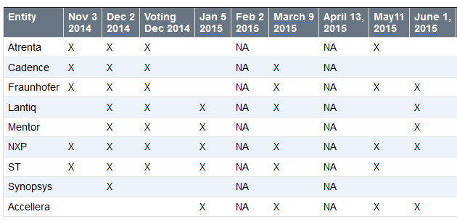

* Entities represented today: NXP, Fraunhofer, Accellera, Lantiq, Mentor
* Entities with voting rights (attend last two consecutive meetings): NXP, Fraunhofer, Accellera
* 5 of 3 eligible voting entities represented. Quorum achieved.

**3. IEEE-SA patent policy and call for patents**

* Martin presents a slides 1-4 of the IEEE patent policy. More information in  
  <http://standards.ieee.org/board/pat/pat-slideset.pdf>
* Please study the IEEE-SA patent policy and patent related links:
  + IEEE-SA Standards Boards Bylaws: <http://standards.ieee.org/develop/policies/bylaws/sect6-7.html#6>
  + IEEE-SA Standards Board Operations Manual: <http://standards.ieee.org/develop/policies/opman/sect6.html#6.3>
  + Material about the patent policy: <http://standards.ieee.org/about/sasb/patcom/materials.html>

*Call for Potentially Essential Patents*

None of the participants is personally aware of the holder of any patent claims that are potentially essential to implementation of the SystemC AMS standard.

**4. Approval of the agenda**

Motion to approve the agenda. Motion to approve: Karsten. Second: Gerhard. Agenda approved.

**5. Approval of previous meeting minutes**

Minutes can be found here: http://www.eda.org/twiki/pub/P16661/January5%2c2015/p16661_minutes_2015_05_11.docx

Motion to approve: Karsten. Second: Joe. Minutes approved.

**6. SystemC AMS technical documentation update**

* Draft 2 available of P1666.1 SystemC AMS LRM
* Content update
  + CR980 added
  + CR1062 added
* IEEE stylesheet improvements
  + Title page, IEEE notices, header/footers, Index, etc.
  + Still some items TODO
* Draft 2 available in private space on Twiki:  
  <http://www.eda.org/twiki/pub/P16661/MemberArea/P1666.1_D2_June_1_2015.pdf>
* Change requests updates
  + CR980: Initial value of vector – **DONE – Please review**
  + CR1006/1061: remove hierarchical decoupling port – **DONE – Please review**
  + CR1036: Add sc_in/sc_out constructors – **DONE – Please review**
  + CR1046: rename phi0 -> psi0 – **DONE – Please review**
  + CR1053/1054/1055/1056/1059: remove argument names when not used in text– **DONE – Please review**
  + CR1060: add ac_processing to text – **DONE – Please review**
  + CR1062: Semantics of delay changes – **DONE – Please review**
  + CR1063: sca_module argument should be const-ref – **DONE – Please review**
  + CR1067: Initial value of CT port at t=0 – **DONE – Please review**
  + CR1070: Remove const-ness for argument for assignment operator= converter and decoupling output ports – **DONE – Please review**
  + CR1071: Define access function for ac and ac-noise simulation for the decoupling ports sca_out<T,SCA_CT/DT_CUT> – **DONE – Please review**
  + CR1072: Make read methods of converter ports and trace variable object consistent (non-const) **TODO: NEEDS DISCUSSION/INPUT**
* Change request updated document: <http://www.eda.org/twiki/pub/P16661/MemberArea/change_requests_scams_for_ieee_1666_1_v5.pdf>
* Anticipated timeline for P1666.1 LRM
  + May 11, 2015: First draft available; review can start
  + June 1, 2015: Second draft planned; 2nd round review;
  + July 6, 2015: All change requests implemented, finalize IEEE typographical updates; Freeze technical content/update; final WG review;
  + August 2015: P1666.1 working group ballot to ratify the standard
  + Sept/Oct 2015: Transfer document to IEEE for formal balloting process
* Discussion:
  + CR980:
    - Add the text “add zero time” before t=0.
    - Should be “initial calculated value” instead of “last calculated value”
  + CR1062:
    - Karsten questions the need for 3rd bullet. All functions called in change_attributes are becoming effective during the next cluster execution. Therefore there is no reason to add this here.
    - Karsten will study the origin of this request and will report its findings.
    - For the delay increase, we need to state that the new samples are uninitialized.
  + Martin to make proposal for CR1072 and starts discussion via reflector
  + Joe mentions that before the formal ballot, a MEC (Mandatory Editorial Coordination) review is conducted. At this stage, the document should comply with IEEE stylesheet rules.
  + Martin will work on Draft 3, release planned early July.

**7. AOB**

* Attendance tracking page on Twiki:
  + <http://www.eda.org/twiki/bin/view.cgi/P16661/AttendanceTracking>
  + Please let me know if your company attendance is not tracked correctly
* No AOB of attendees

**8. Next meeting**

* July 6, 2015 at 17:00h CEST.  
  <http://www.eda.org/twiki/bin/view.cgi/P16661/July6%2c2015>
* Invite will follow.

**9. Adjournment**

Meeting adjourned at 17.46h CEST.